Topic 10: Manager Selection, Due Diligence and Regulation

Hedge Fund Investing: A Quantitative Approach to Hedge Fund Selection and De-Selection



* Hurst portfolio
* Hurst exponent
* D-Statistic
* Omega
* CPR – The cross-product ratio captures the ratio of the managers that show persistence to the managers that do not.
* Calmar Ratio: Max. draw down in denominator
* Sortino Ratio: Downside Target in denominator

1. Describe the goal of the study by De Souza and Gokcan, the criteria they used to choose the data and general dispersion and volatility characteristics of the returns data.

* Mean, standard deviation, skewness, average values for bottom quartile, average values for top quartile and inter-quartile ranges.
* Use higher order moments of the return distribution to draw conclusions about the viability of fund managers
* De Souza and Gokcan (2003) exhibit through a regression on the TASS database that assets under management have a positive relationship with performance. According to them, this could imply that poor performing funds have difficulty attracting new contributions, or that large size allows lower average costs to be obtained.

2. Identify the type of strategies that are most likely to display large dispersion of performance among hedge fund managers. Discuss the implications of the observed dispersion among managers.

* HIGH dispersion: equity long/short and/or Global Macro strategies.
* LOW dispersion: merger arbitrage and/or equity market neutral.

3. Describe the Hurst exponent (in next section) and explain how contingency tables are constructed to analyze persistence and compare the degree of persistence found in hedge fund returns, the volatility of hedge fund returns, and Sharpe ratios.

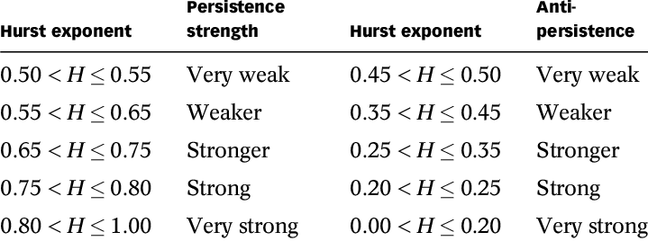

* Cross Product Ratio

* The contingency table-based methods are based on the construction of tables of winners and losers.
* Winners are funds whose performance is higher than the median return of all funds following the same strategy over this period, and losers are funds whose performance is lower than the median performance of all funds following the same strategy.
* Z-Score
* In mathematical terms, the Z-score tells you how many standard deviations away from the average a particular data point falls. Here’s the formula used to calculate a Z-score:

* The SORTINO ratio has been advocated to better account for the asymmetry of hedge fund return distributions. It is similar to the Sharpe ratio, replacing the standard deviation with the downside deviation.

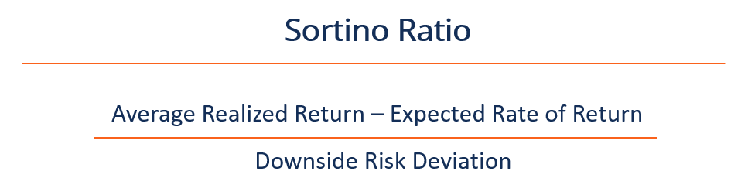

* The CALMAR ratio is a measure of risk-adjusted returns for investment funds, created by fund manager Terry Young in 1991.
* The Calmar ratio uses a fund’s maximum drawdown as its sole measure of risk, which makes it unique. This could also be considered one of its weaknesses.
* On the flip side, the Calmar ratio's focus on drawdown means it's view of risk is rather limited compared to other gauges, and it ignores general volatility. This makes it less statistically significant and useful.
* The Calmar ratio is most similar to the Sterling ratio in its calculation, it takes the average annual compounded rate of return and divides it by the maximum drawdown for that same time period, usually over a period of 3 years (however when 3 years worth of data is not accessible, then the available data is used). Like many of the other risk statistics, the higher the Calmar ratio the better with anything over 0.50 is considered to be good. A Calmar ratio of 3.0 to 5.0 is really good.

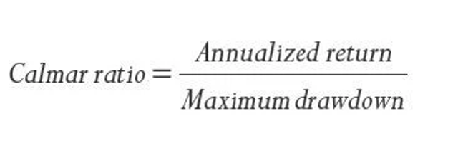

* STERLING ratio is another helpful risk adjusted statistic, however it is less widely used within the investment universe. Like the Sharpe and Sortino ratio’s, the Sterling ratio looks to quantify risk to reward. The Sterling ratio, however, takes a slightly different approach then the Sharpe and Sortino. The Sterling ratio is calculated by taking the compound annualized return over the last 3 years, and dividing it by the average yearly maximum drawdown over the last 3 years, less an arbitrary 10%.
* To calculate the average yearly drawdown, the latest 3-year returns (36 months) are divided into 3 separate 12-month periods, and the maximum drawdown is calculated for each. These 3 drawdowns are then averaged to produce the average yearly maximum drawdown for the 3-year period. (If there are not 3 years of data, the available data is used). Like many other risk adjusted statistics, the higher the Sterling ratio the better, showing that the investor is earning a higher return relative to the risk

Note: “Sterling Ratio”

4. Describe the algorithm for risk budgeting used by De Souza and Gokcan and contrast the approach with the typical approach to risk budgeting.

* Express risk-based allocation to each risk class as a function of the volatilities
* Returns not taken into consideration

5. Explain how the Hurst exponent and D-statistics are calculated and are used to analyze hedge fund performance and develop portfolios.

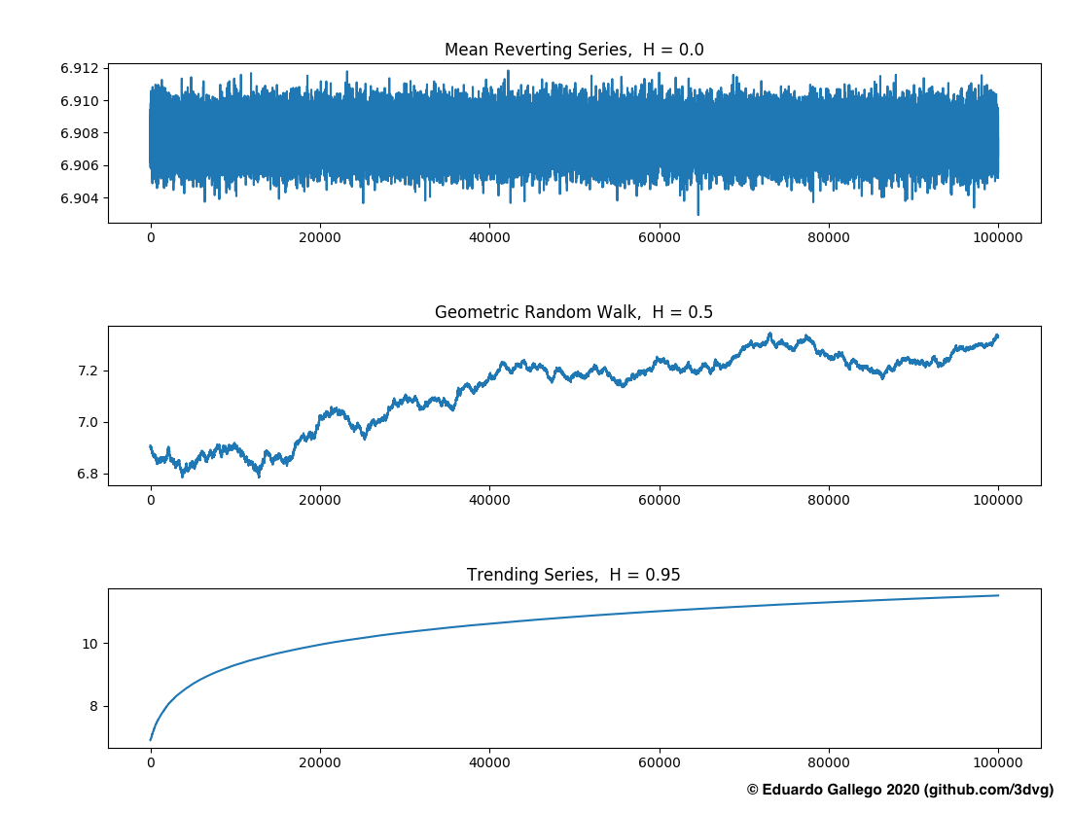

Note: “Reverts to a trend”

The HURST exponent is a measure of whether a trend (negative or positive) will persist or mean revert to some historical average.

* 0 to .5 = not persistent. Mean reverting.
* .5 = random
* .5 to 1 = persistent
* Hurst Ratio = log M / (log N - log a)

D-STATISTIC is used with the Hurst exponent. It separates good persistence from bad persistence.

* The D-statistic thus defined ranges from 0 to 1, with D = 0 representing a return distribution with no downside risk and D = 1 representing one in which a manager has no positive returns.
* We therefore are predisposed to managers with low D-statistics.
* d-Ratio = Abs (d/U) where, d = number of returns less than zero times their value U = number of returns greater than zero times their value Abs = absolute value.
* We have earlier highlighted that the high skewness of a hedge fund's returns may be connected to the hedge fund manager's selection of high-reward and low variance opportunities.
* The d-Ratio compares the value and frequency of a manager's winners to losers to capture the skewness in returns.
* This statistic, which does not require any assumption of the underlying distribution, may be used as a proxy for a fund's risk, with d=0 representing a distribution with no downside, and d = infinity representing one in which the manager does not make any positive returns.

6. Apply DeSouza and Gockan’s quantitative model for due diligence pre-screening.

* The authors merge DEAD funds in the TASS database with LIVE funds with the goal of identifying the different characteristics of surviving funds vs. dead funds

Most likely to liquidate:

* young funds
* poor performers
* no high watermark
* short redemption notice periods
* The high-water mark ensures the manager does not get paid large sums for poor performance. If the manager loses money over a period, he must get the fund above the high-water mark before receiving a performance bonus from the assets under management (AUM).

7. Explain the Omega measure.

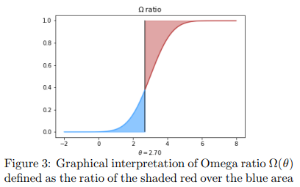

* Omega monitors the risk of the fund over time. It takes into account the distribution of returns and all of the movements. Skew and Kurtosis.
* Measures the robustness of results.
* Introduced in 2002 by Keating and Shadwick, the Omega ratio is a relatively new addition in a hedge fund metrics library. By employing higher moments and taking into account actual shapes of distributions of returns, this measure is well-suited for hedge fund risk assessment, because of the non-normality of their distributions.
* The Sharpe ratio considers only the first two [moments](https://en.wikipedia.org/wiki/Moment_(mathematics)) of the return distribution whereas the Omega ratio, by construction, considers ALL moments.

The Fundamental Principles of Financial Regulation

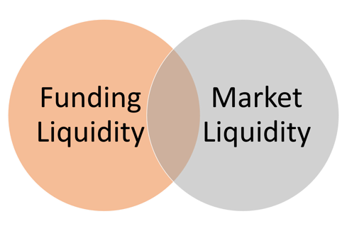

* Contagion
* Fire-sale externalities
* Funding liquidity
* Interconnectedness externalities
* Market liquidity
* Maturity mismatch
* Procyclical leverage
* Repo haircuts

1. Explain and compare the following terms:

* Solvency
* Funding liquidity
* Market liquidity
* Maturity mismatch

2. Explain how attempts by individual institutions to remain solvent can push the financial system into collapse.

* Bank A loans to Bank B.
* Bank A experiences a downgrade.
* Domino effect

3. Asses the domino model as it relates to funding liquidity.

* Domino model is a form of financial contagion where the fate of one financial institution impacts the fate of other financial institutions.
* Studies of the domino model have concluded that the impact of CONTAGION is SMALL.

4. Explain the relationship between loss spiral (balance sheet spiral) and asset price movements at times of financial crisis. ESSAY

* An asset price change that causes one institution to suffer losses may also affect other institutions even though the institutions have not make loans to one another.

5. Identify the role of margin/haircut and its fluctuations in the loss spiral process and the degree of funding available to leveraged institutions.



* Repo haircuts are of particular interest due to the widespread use of repurchase agreements as a primary financing tool for market-based banks.
* A repurchase agreement, or 'repo', is a short-term agreement to sell securities in order to buy them back at a slightly higher price.
* The one selling the repo is effectively borrowing and the other party is lending, since the lender is credited the implicit interest in the difference in prices from initiation to repurchase.
* Repos and reverse repos are thus used for short-term borrowing and lending, often with a tenor of overnight to 48 hours.
* The implicit interest rate on these agreements is known as the repo rate, a proxy for the overnight risk-free rate.
* Excessive reliance on short-term repos such as overnight or open repos was a principal source of the liquidity problems at Bear Stearns and Lehman Brothers. This short-term funding strategy resulted in a so-called “run on the repo” during the 2008 financial crisis.

6. Describe the three reasons why MARGINS increase when asset prices drop.

1. Risk measures are backward looking

2. Volatility may vary across time

3. Adverse selection from asymmetric information

7. Describe externalities and explain when the existence of externalities provides a rationale for regulation.

* In economics, an externality is a cost or benefit that is imposed on a third party who did not agree to incur that cost or benefit.
* Interconnectedness externalities
* The concept of externality was first developed by economist Arthur Pigou in the 1920s. Air pollution from motor vehicles is an example of a negative externality.

8. Differentiate financial institutions based on objective risk-spillover measures.

1. Causes difficulties at other entities
2. Financial difficulties are correlated

9. Contrast the rules for individually systemic institutions to those for institutions that are “systemic in a herd.”

* An ideal measure would account for left-tail co-risk rather than simple variance.
* Micro prudential regulation
* Individual institutions are subject to risk limits and the same macro prudential regulation as individually systemic institutions.
* Individual institutions are not subject to micro prudential regulation but are subject to simplified mac or prudential regulation that relates core capital to leverage and the rate of asset growth.